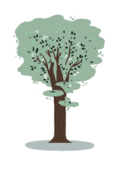
Stoneraise School
Class Beech Newsletter
Spring 1st Half Term

Dear Parents,

Firstly, I want to wish you all a Happy New Year and I hope you had a lovely time over the Christmas holidays! But I am sure you are ready for the return of some normality!

What is the weather like?
Key questions:

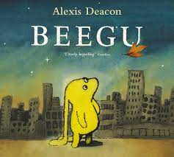
Our Topic for this half term is What a wonderful world and will run parallel alongside our Science as our main focus under this ‘umbrella’ will be weather and seasons. Class Beech will be learning about weather symbols, the seasons, measuring and collecting data about the weather. Using this knowledge, we will start to compare hot and cold places in the world and why the weather/seasons differ.

In English our main text will be Beegu – he will crash land at school! We will be writing letters to him, creating poems and create our own versions of an alien story!

To begin with in Maths the children will be consolidating their knowledge of numbers to 20 and using this to add and subtract using different methods. By the end of this term, we will move into working with numbers to 50.

Homework
- Please continue to listen to your child read at home and record in their book so that when we read with them, we can make the appropriate book changes!
- Mathletics homework will be assigned every Monday for the week and will be outlined on our Weekly email.
- Continue to practise the RWI resources that are sent home with your child.

Our PE session on a Thursday will follow the theme of throwing and catching this term, with the Tuesday with Carlisle United.

I am in the process of planning some trips over the next few terms and will contact you with the arrangements in due course. If you have any questions, concerns or anything you wish to speak to me about in relation to your child and their learning, then I am always more than happy for you to contact me.

Many thanks,
Miss Samantha Tremble and Mrs Sue Blair.
stremble@stoneraise.cumbria.sch.uk

